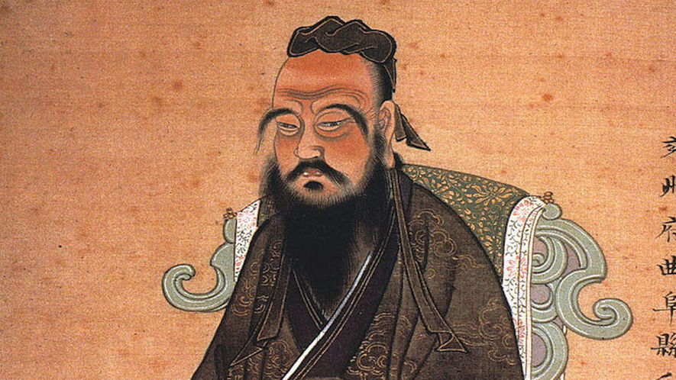
Synopsis
Confucius was born in 551 B.C., in the Lu state of China. He became an important philosopher, someone who studies knowledge, truth and the meaning of life. His teachings focused on creating models for good behavior and setting educational standards. He died in 479 B.C. Confucius' ideas later had a strong influence on Chinese customs and government.
Early Life
Confucius was born around 551 B.C. in present-day Qufu, China. Little is known about his childhood. A book called "Records of the Historian" offers the most detailed description of Confucius' life. However, some modern historians believe this book is more myth than fact. The book claims that Confucius was born into a royal family of the Chou Dynasty. A dynasty is a line of rulers from the same family. Other records say that Confucius was born into poverty. What is undisputed about Confucius' life is that he lived during a time of crisis in China.
Philosophy And Teachings
Over 2,500 years ago, China's Chou Empire began to fall apart. It had been in power for over 500 years. But warring Chinese states eventually led to its breakdown. Traditional Chinese values then began to decay, resulting in a period of moral decline. Confucius saw this as an opportunity to strengthen the old Chinese values and customs. His ideas were based primarily on the principle of "ren," or "loving others," while practicing self-control. He believed that ren could be put into action using the Golden Rule. The Golden Rule is "do not do to others what you do not wish for yourself."
Confucius’ political beliefs were also based on the idea of self-control. He believed that a leader should practice self-control in order to stay humble and treat his followers with care. In doing so, he would set a good example. Confucius thought leaders could encourage people to follow the law by teaching them morals and good manners.
His principles of education focused on different arts of the time, like math, archery and music. Confucius believed a teacher should show people how to live with honesty and decency. He tried to bring back the old values of kindness and courtesy.
Major Works
Confucius wrote and edited some of the most important Chinese books. These include his edited copies of the "Book of Odes" and the "Book of Documents." He also put together a record of the 12 dukes of Lu, called "The Spring and Autumn Annals." Confucius' own followers wrote down his ideas in the "Four Books." One of these was translated into English as "The Analects of Confucius." It contains Confucius' sayings and ideas. It had a big effect on Chinese life and customs.
Death And Legacy
Confucius died in 479 B.C., in Qufu, China. His followers held a funeral and held a period of mourning in his honor. In the years that followed, Confucius came to be regarded as a man of wisdom. During China’s first Han Dynasty, his ideas became the foundation for the state government. Today, he is widely considered one of the most important teachers in Chinese history.

- Write a 25-word summary of the article

- Pick a golden line from the article (a line that really stands out to you as important). This can be a full sentence, part of a sentence, or even a short phrase. Write it below.

- Explain why you picked that golden line:

