Ancient Mesopotamia
Southwest Asia (Middle East) Geography
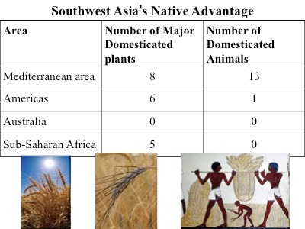
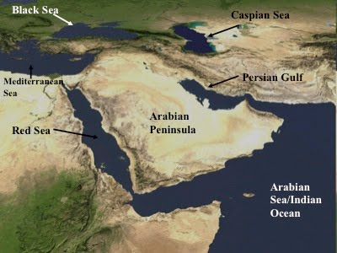
Most of Southwest Asia has an arid climate today. An Arid climate receives less than 10 inches of precipitation (rain, sleet, or snow). Arid areas are usually covered in desert and often experience very high temperatures. This region was not always covered in desert. Ancient Mesopotamia was a green land where many plants grew due to the rich soil and occasional rain. The rich plant life allowed many animals to live in this region. People living here hunted and gathered the animals and plants. Ancient Mesopotamia and the surrounding area is often called the Fertile Crescent or the Cradle of Civilization. The Tigris and Euphrates rivers supplied fresh water for humans, plants, and animals. Eventually these rivers would provide irrigation for the farms of the first civilization in human history. The word Mesopotamia is Greek for 'land between rivers'.
Agriculture
Around 8,000 BCE (BC), people began to slowly discover that planting a seed would make a new plant grow—the beginning of farming! The main reason farming probably began in this region is because Southwest Asia had several types of wild grain that can be farmed—we still use them today! The slow process of taking a plant from the wild and turning it into a farm crop is called domestication. For example, corn was domesticated in Mexico around 7000 BCE (BC). Farmers in Mesopotamia grew barley, wheat, lentils, chickpeas, onions, garlic, dates, and lettuce. Not every plant can be domesticated. Southwest Asia had more wild plants that could be domesticated than any other region, and they had the same advantage when it came to animals. 13 out of the 14 main domesticated animals today were native to Southwest Asia. Native means originally from a particular area. People in Mesopotamia domesticated sheep, goats, cows, donkey, oxen, and pigs.
It is believed that people first began farming around 8000 BCE. Southwest Asia was the first place farming developed. Farming produces much more food than hunting and gathering because a few farmers can grow enough food for an entire village. Since farming requires constant attention, farming people couldn’t be nomadic. Nomadic people don't have a permanent home, so farming forced people to settle down and live in one place. These new farmers usually settled along a river for the fresh water and fertile soil, in this case the Tigris and Euphrates Rivers. Slowly, more people moved into these areas and villages or small towns began to develop. The world’s first cities may have developed as early as 10,000 BCE—in Damascus or Jericho. However, these individual cities do not qualify as a civilization. A civilization means several cities and usually a common culture between all of the cities. Mesopotamia is different than most civilizations since they develop city-states. A city-state is a nation that is only one city. Mesopotamia was a collection of cities, and they shared many aspects of culture.

Ancient Mesopotamia
Mesopotamia's First Civilization--Sumer
Around 3500 BCE, people were growing more food than they needed, which allowed the division of labor. People were living in multiple cities with governments and religions. A written language developed around 3300 BCE—civilization is official! The first civilization to develop was called Sumer in southern Mesopotamia. Sumer was a collection of city-states, most of them with thick defensive walls because the city-states were often at war with one another. Major cities included Eridu, Uruk, Ur, and Lagash. Uruk was one of the largest cities; at one time it may have had 80,000 people living in and around the city. This time period began a great human migration from the countryside into the city.
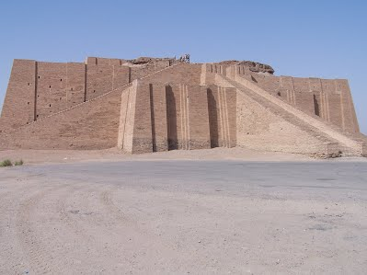
Mesopotamia invented new technology. They were the first to use the wheel. The wagon was a transportation revolution for farming and trade. They developed a number system based on 60--this explains why we have 60 seconds in minute and 60 minutes in an hour. They used a 12 month calendar with a 7 day week. Astronomers studied the stars and mapped the first set of constellations. Early writers wrote the earliest known literature called the Epic of Gilgamesh, which tells the tale of the struggle between man and the Gods. They also created architectural structures such as the dome, the column, and the arch. Architecture is the art of building structures (buildings of any kind). All that remains today of most Mesopotamian architecture are mounds of dirt and clay called a “tell”--broken mud-brick buildings in modern-day Iraq. This is why the architecture of Mesopotamia is hard to find today. The mud-bricks have eroded away, but archeologists have uncovered amazing artifacts under the ruble that tell the story of these ancient people. A tell is also a good place to look for graves. We have learned a great deal about Mesopotamia and other civilizations from exploring their burial grounds.

Social Hierarchy of Sumer
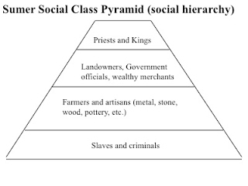
Sumer was not the only group to develop in Mesopotamia, but their culture influenced future civilizations. The government was organized around one king, the man dominated the household, and their religion believed in some kind of afterlife. Their culture had social classes—groups of people with similar backgrounds, wealth, and ways of living. Social classes were formed when people began doing different jobs. The jobs made them live in different ways, wear different cloths, and earn different amounts of wealth. All of these culture characteristics would be passed on.
In Sumer, the city became the center of trade, religious, and social life. The city layout reflected the rank of developing social classes. At the center of each town was a religious temple called a ziggurat. Palaces for the king's family surrounded the temple. Homes and shops for government workers, scribes, and craftsman surrounded the royal palaces. Smaller houses were usually found on the outsides of the city, but still in the large defensive walls that surrounded the city. Narrow alleys and small streets divided the houses.
The religion was slightly different in each city-state, but all of them were polytheistic. Polytheism is the belief in many Gods. They believed the Earth was a flat disc and the sky had holes that showed the light of heaven above. They believed their kings descended from the Gods. They buried their important people with their personal belongings and sometimes their servants. One grave had nearly 70 servants who were buried with their leader.
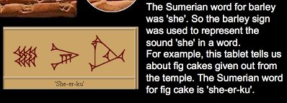
Writing in Cuneiform
Over five thousand years ago, people living in Mesopotamia developed a form of writing to record different types of information. The earliest writing was based on pictures that represent words or phrases—these are called pictograms. Pictograms were used to communicate basic information about crops, taxes, and lending (loans). This type of writing required hundreds of symbols. Over several hundred years, the pictures developed into a type of writing we call cuneiform. Cuneiform was different because the symbols now stood for sounds, similar to our alphabet. At some point scribes began using a new wedge-shaped tool to press into the wet clay tablets. Paper had not been invented so they wrote on wet clay tablets. Scribes were the only people who knew how to read and write. Over thousands of years, Mesopotamian scribes recorded daily events, trade, astronomy, and literature on clay tablets. The first alphabet would develop around 1000 BCE by a different civilization along the Mediterranean called Phoenicia. All modern alphabets can be traced back to this extremely important development in writing.

The countryside farmers grew food for themselves and everyone in the city. In this dry region they depended on the regular flooding of the Tigris-Euphrates Rivers. They used careful irrigation to save water in pools and canals to keep for later use during dry times. Irrigation is a way to water fields without rain. Most of the farmers grew grain crops such as barley or wheat. These wild grasses produced grains that could be ground up to make flour for bread. Peas, garlic, onions, dates, and figs were also grown. The crops were brought to the temple to be stored or to market for trade or sale. Over the next several thousand years, Sumerian civilization influenced the surrounding area. New city-states rose to power in the region such as Akkad, Babylon and Assyria. Each of these cities grew into empires as they conquered the surrounding area and constantly fought each other.

Ancient Mesopotamia
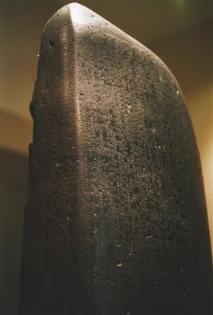
Babylonia
Babylonia came into power when King Hammurabi created an empire out of the former kingdoms of Sumer and Akkad. Babylonia gets its name from their capital city, Babylon. Babylon is probably the most famous city in Ancient Mesopotamia because of its regular mentions in Jewish and Christian religious writings.
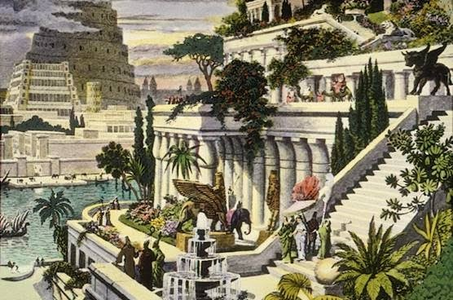
Babylon became known for impressive architecture and its laws and government. A Babylonian king named Nebuchadnezzar II built the Hanging Gardens of Babylon. The Hanging Gardens of Babylon were one of the Seven Wonders of the Ancient World. Nebuchadnezzar II supposedly built these around 600 BC because his wife missed the forests and jungles of her home. The gardens didn’t actually hang—they were simply built on top of towers, platforms, and temples. The plants hung down the side and gave an appearance of “hanging” plants. Hammurabi is also known for creating a system of laws called the “Code of Hammurabi” that has had a lasting influence on legal thought. Only one example of the Code survives today on a seven foot, four inch tall basalt stone slab. The Code is considered an early form of what is now known as a constitution. There are 282 laws in the Code of Hammurabi. After Hammurabi, Babylon was conquered by the Assyrians and controlled for centuries until they finally recaptured and increased their empire in 627 BCE.
Assyria and Persia
Assyria was in the Upper Tigris River in modern day Iraq and Turkey. They were a powerful military empire that came to rule a large empire, including Ancient Egypt, a number of times in history. The main Assyrian cities of the middle period were Ashur, Kalhu (Nimrud) and Nineveh. The Assyrian empire has been described as the first military power in history. Assyrians were the first to manufacture metal wheels, which was much more durable and therefore able to be used in war. The core of the Assyrian army was their war-chariots. The Assyrians were also the first to use camels in war.
Persia became a powerful empire when they defeated Assyria. Persians gained control of most of Mesopotamia and even Ancient Egypt, and created the largest empire in the ancient world. Persia developed in modern day Iran. Persia controlled an area that stretched from the Indus River (Pakistan) to beyond the Nile. The Persian Royal Road was an ancient highway that allowed rapid communication throughout this very large empire. Messengers on horseback could travel the 1,677 miles in seven days; it took ninety days on foot. The road also helped Persia increase long distance trade and eventually became a major part of the Silk Road.
Persia was a major contributor to early science. Persian scientists worked on understanding nature, medicine, mathematics, and philosophy. Persians made important contributions to algebra and chemistry. Zoroastrianism was a major religion found in ancient Persia as early as 5000 BC. Zoroastrianism was one of the first monotheistic religion—or belief in only 1 god. Zoroastrianism greatly influenced the Abrahamic religions—Christianity, Islam, and Judaism. About a quarter of a million people still follow this religion. Judaism developed near the Mediterranean around the same time. Judaism would eventually give rise to Christianity and Islam.
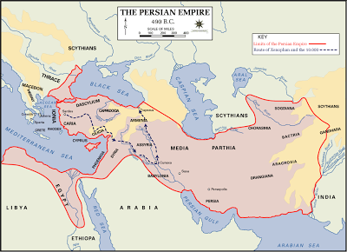
Ancient Egypt
North Africa Geography
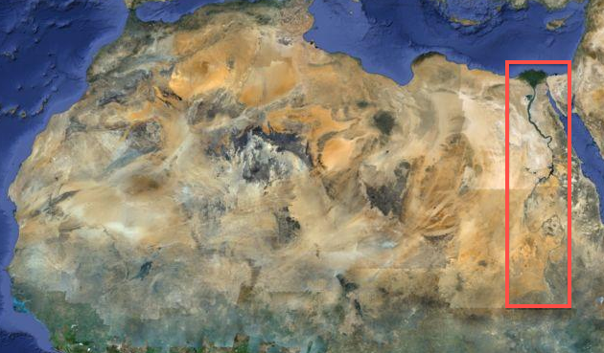
North Africa's landscape is covered by the world's largest hot desert--the Sahara. This massive Arid climate makes it a strange place for a large population of people. Most of the Sahara is too harsh for people to live. The Nile Valley, coastal areas, and the rare oases (plural for oasis) provide the only places that can support life. An oasis is an area of natural water in a desert that allows plant life. The Nile is the world’s longest river. It flows north through the Sahara creating a long oasis in the desert eventually dumping into the Mediterranean Sea. The Nile’s water comes mainly from highland areas near the center of Africa that receives frequent rain, which flows north, downhill into the Nile. The Nile is divided into sections by cataracts. A cataract is a rocky area that creates a waterfall or rapids. There are six cataracts in the Nile river.
For thousands of years the Nile has flooded when the rainy season begins in central Africa. The Nile flows over the riverbanks and after several months it soaks into the ground, evaporates, or flows into the Mediterranean. As the water level lowered, it would leave behind rich fertile soil for farmers. The flooding usually began around June and it happens every year, so it was a dependable source of water and fertilizer for farmers. Egyptians dug canals to pull water out of the flooded river, which they saved for irrigation later on. It doesn't rain in the Sahara, so Egyptians relied completely on irrigation from the Nile to farm. Fresh water, irrigation, fertile soil--this is why people called it the "gift" of the Nile.
Early History
The oldest human fossils have been found near North Africa, but the land was very different 200,000 years ago. 10,000 years ago North Africa was a grassland with many plants and animals. North Africa took its current desert form around 6000 BCE. Around 6000 BCE the climate began to change, which might explain why humans changed from hunting and gathering to farming. Before civilization, early humans came to the Nile River to hunt, fish, and gather food, but gradually as people learned to farm and domesticate animals (about 7000 BCE and 5500 BCE), and therefore live in permanent settlements, areas around the Nile became more crowded. Several towns grew and eventually kingdoms developed. The change from nomadic hunter-gatherers to civilized living followed the same pattern as other places around the world: farming provided extra food, which allowed the division of labor, which allows the development of government and religion and creates social classes.

Ancient Egypt
Egyptian Civilization
Starting around 5500 BCE two major kingdoms developed along the Nile. Historians call them Upper Egypt and Lower Egypt. Around 3200 BCE, Egypt was brought together under one ruler—King Narmer (sometimes called Menes). This is recognized as the beginning of the Egyptian civilization. We know so much about the Egyptians because there are so many written resources and because their culture lasted so long with few interruptions. Mesopotamian culture was constantly changing and disrupted by war. Another reason we know so much about Egypt is because they made their architecture out of stone, which has lasted for the most part.
Egyptian Religion
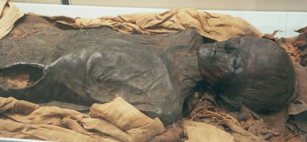
Religion was at the center of Egyptian life. Egyptians believed in many Gods, so they were polytheistic. The Egyptian king was the absolute ruler, and owner of all the land, water, people, etc. in his or her kingdom. Later Egyptians would call their kings “pharaoh”. Egyptian people believed the pharaoh was a living God, so the Egyptians developed a theocracy, or a government ruled by religious leaders. This is important to understanding why Egyptian people were so willing to give their grain to the Pharaoh and build him or her incredible temples—they thought the Pharaoh was a living God that would be with them forever in eternity. The first pharaohs established a dynasty, or family control of government, and a capital city at Memphis from which they could control the work force, agriculture, and trade routes in and out of Egypt. A total of 31 dynasties controlled Egypt during nearly 4000 years of history. Egyptians had many religious rituals and ceremonies. The most well-known ritual was mummification. Egyptians believed in life after death, and they wanted the body to look life-like. Anyone could be mummified if they had enough money. First they removed the organs. Then they removed as much moisture from the body as possible using a salt called natron to preserve the body and then wrapped it in linen cloth. The body was placed in a sarcophagus, which is similar to a coffin.
Egyptian Society
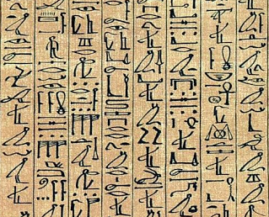
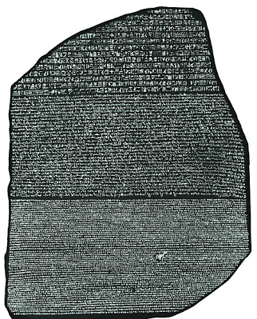
Egyptians were a very advanced civilization due to their inventions and technology. Egyptians developed a writing system called hieroglyphs that combined pictures and symbols. Eventually, they created an alphabet from their symbols. In 1822 CE a European explorer found what is called the Rossetta Stone--a stone with the same message written in 3 different languages, which finally allowed historians to translate ancient hieroglyphs. Egyptians developed a 365-day calendar and used a number system based on 10. Egyptians figured out amazing ways to cut stone to use in their temples and obelisks. An obelisk is a tall narrow monument that becomes more narrow as it goes up. They created a writing material similar to paper called papyrus from reeds found in the Nile. Egyptians were excellent ship builders and excelled at mathematics. They used fractions, decimals, addition, subtraction, multiplication, division and basic ideas of geometry. Egyptian art and architecture is famous and has been reused and copied by many other civilization including Greece, Rome, and even the United States.
Egyptian life depended on what social class you were a part of. At the top of society was the Pharaoh. Below the Pharaoh was the royal court (Pharaoh's family), high priests, government officials, and scribes and nobles (rich land owners). Below them were doctors and engineers, craftsman, and then farmers and unskilled workers at the bottom. Egyptians did use some slaves, but slavery is hardly mentioned in their writings. Most people lived in mud-brick homes. Women raised the children and men usually made an income for the family. Egyptians enjoyed music, dancing, and playing games such as Senet. When farmers were not working the fields they often worked on construction projects including temples and irrigation canals. Bread was the main food source, but they would have eaten meat during festivals.
Ancient Egypt
Ancient Egypt's History
Egypt's history is divided into six different time periods. Old Kingdom, First Intermediate Period, Middle Kingdom, Second Intermediate Period, New Kingdom, and the Third Intermediate Period. The “Kingdom” periods were times of peace and prosperity when new temples were built, plenty of food was harvested, and things were basically good. “Intermediate” periods were times when Egypt was invaded, experienced civil war, bad food harvests, or other difficult times. Historians call the time period before the Old Kingdom the Early Dynastic Period. During this time, the first Pharaoh Narmer started the tradition of passing power to members of his family, usually the son--creating Egypt's first dynasty. He defeated some enemies and united Upper and Lower Egypt into one civilization. Egyptians didn't build pyramids during this time, but they did build a burial building called a Mastaba. A Mastaba has a flat roof, similar to the base of a pyramid without a top. The building of a Mastaba clearly led to the building of pyramids during the Old Kingdom.
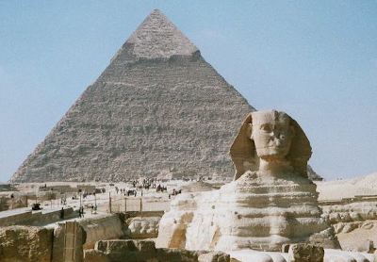
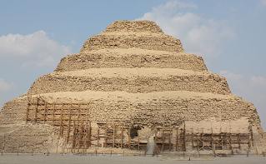
The Old Kingdom includes the 3rd dynasty through the 6th dynasty, which lasted from 2686 BCE to 2181 BCE. During this time the Egyptian kingdom was divided into states or provinces called nomes. One of the first major Pharaohs of the Old Kingdom was Djoser. His temple was one of the first pyramids Egyptians tried to build. It was a "step pyramid" and it started the tradition of building pyramids as a burial ground for Pharaohs. The more well known pyramids at Giza and the Sphinx were built for Pharaoh Khufu during this time. Old Kingdom Pharaohs had complete power and were treated as living Gods. During this time Ra became the most important Egyptian God. The pyramids were meant to honor the Pharaoh, but also keep his grave safe from robbers. Towards the end of the Old Kingdom a period on instability began the First Intermediate Period.
Middle Kingdom
The Middle Kingdom includes the 11th, 12th, and 13th dynasties which lasted from 2055 BCE to 1650 BCE. The eleventh dynasty ruled from a new capital city called Thebes. A new capital city was created with the 12th dynasty. The Pharaohs of the Middle Kingdom were less powerful and the Old Kingdom Pharaohs. The leaders of each nome (nomarch) became more powerful. The Middle Kingdom was a busy time for the Egyptian military. They made several invasions into Nubia, which is south of Egypt in the modern nation of Sudan. They also moved military forces into Asia across the Sinai Peninsula toward Jerusalem and Jericho. Some smaller pyramids were built during this time, but since grave robbers were able to break into the old pyramids, these large expensive structures were ineffective. Toward the end of the Middle Kingdom Pharaohs were buried in hidden tombs, many still undiscovered. The Middle Kingdom ended when foreign armies called "hyksos" in the north and began the Second Intermediate Period.
New Kingdom
The New Kingdom includes the 18th, 19th, and 20th dynasties, and lasted from 1550 BCE to 1069 BCE. Egyptians kicked out the "hyksos" and wanted to stop foreign invaders, so they pushed their military far into Asia and battled with the Assyrians in Mesopotamia. They also invaded southern areas of the Nile often called the "Punt" where Nubian Kingdoms and Kush Kingdoms could be found. This military expansion created the largest Egyptian Empire of their history, but it would be hard to maintain. Some of the most famous Pharaohs of Egyptian history ruled in the New Kingdom, in fact it was during this time that Egyptian kings began to be called "Pharaoh". Hatshepsut was a women Pharaoh. Her tomb is an amazingly long ramp leading to a temple that has been cut out of a mountain. Pharaoh Akhenaten tried to start a new religious tradition of worshipping only one God. Worshipping one God is called monotheism. This did not sit well with the polytheistic population. Pharaoh Tutankhamen also ruled during the New Kingdom--he is known and King Tut.
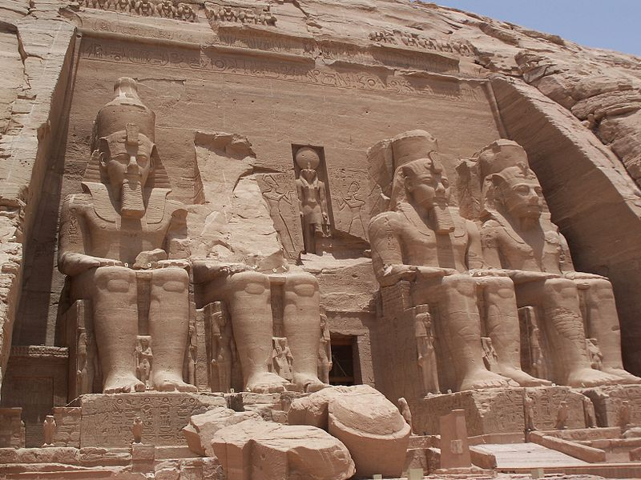
During the 19th and 20th dynasty of the New Kingdom many of the Pharaohs were named Ramsses. Ramsses II was probably the greatest Pharaohs in Egyptian history--They call him Ramsses the Great. He had an amazing tomb build in Abu Simbel with massive statues or Ramsses the Great. It took over 20 years to build this temple, which was next to the river to serve as a warning to anyone trying to invade his kingdom. A few different invasions in the north weakened the empire and used up their resources--this began the Third Intermediate Period.
Foreign Control
The amazing and mysterious civilization lasted from around 3200 BCE until about 525 BCE before outsiders completely conquered them. Even after they were conquered Egyptian culture existed until about 300 CE (AD) before it was replaced with Greek, Christian, and later Islamic culture. Egyptians went on to create one of the most advanced civilizations that included some of the world’s most amazing art and architecture—the art of building structures or buildings.
Attacks from nearby civilizations especially Persia, Greece, and Roman took control of Egypt away from Egyptians. One of the greatest stories in history—the story of Cleopatra—tells the tale of how Egypt was under Greek control, but still keeping most Egyptian cultural traditions. Cleopatra wants to become the Pharaoh of Egypt, so she has her brother killed and lures Julius Caesar into a relationship to help her regain power. After many twists and turns, the story ends with complete Roman control of Egypt in 30 BCE when the Roman Emperor Octavian conquered Egypt, officially making it part of the Roman Empire. The story of Cleopatra is one of thousands of exciting stories that make up the 4000 year epic of Ancient Egyptian history.
Roman control of Egypt was the beginning of the end of Ancient Egyptian culture. Rome controlled Egypt for several centuries until Arab Muslims from the Middle East (Southwest Asia) took control. They discouraged they old Egyptian culture and many Egyptians converted to Islam. Over 700 years of foreign control of Egypt, the traditions faded away the language was forgotten, and sand covered up many of the temples. Today Egypt’s culture is completely different. Luckily in the 1800's historians and archeologists began a new adventure to uncover the past of the once mighty Ancient Egypt.
Ancient India
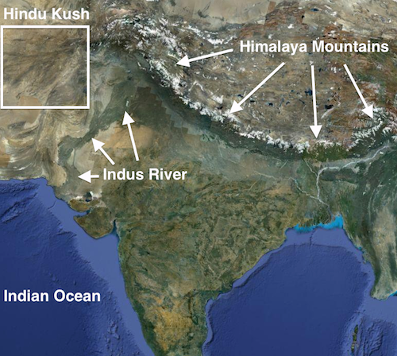
South Asia Geography
South Asia is one of the four early places where human civilization began—similar to Egypt (Nile), China (Yellow), and Iraq (Tigris and Euphrates). Civilization in South Asia began along the Indus River. The land of South Asia is dominated by three main types of physical features. Mountains, rivers, and the massive triangular-shaped peninsula of India.
50 or 60 million years ago India slowly smashed into Asia and formed the Himalaya and Hindu Kush Mountains that nearly block off India from the surrounding area. Except for the coast, there are only a few narrow passes through the mountains such as the Khyber Pass that have allowed people to enter this land. The other main physical features are the Indus River in modern day Pakistan and the Ganges River in modern day India. The Indus River is in a very dry area called the Thar Desert--this Arid climate is the site for another of the world's first human civilizations.
The water in the Indus River mainly comes from melting glaciers and natural springs from the mountains that surround it. As the water runs down the mountain it picks up fertile silt. This area would flood at least one time every year and provide irrigation water for farmers. When the flood waters went away the left a thin layer of fertile silt. Today, much of South Asia experiences an annual change of wind direction called monsoon that usually brings massive amounts of rain. Some historians claim the Indus Valley received two annual floods.
Early History
Some of the oldest human remains in South Asia date back to around 75,000 years ago. These early humans made tools and lived a nomadic hunter/gatherer life. Artifacts indicate that around 5000 BCE, farming developed in South Asia. Slowly, people began to live in permanent places and villages slowly developed—eventually these villages turned into cities and created one of the earliest human civilizations in the world. This civilization is known by many names: Ancient India, Indus Valley, and Harappan Civilization. Historians and archeologists believe the Indus Valley Civilization began around 3000 BCE. There is evidence of trade between Ancient India and Mesopotamia as early as 3200 BCE. This and other evidence suggests Ancient India relied on trade in a larger way than other early civilizations.
Harappan Civilization
Ancient India is often called the Harappan Civilization because one of the ancient cities was called Harappa. Harappa was just one of 1500 cities in the Indus River Valley. Another well-known city is called Mohenjo-Daro. Historians estimate Ancient India to be the biggest of all four early civilizations. This civilization was not discovered until the 1920’s CE, and much of this civilization remains a mystery. One reason the Indus Valley civilization is so mysterious is because historians have not been able to translate their complicated written language called Indus Script. There are thousands of artifacts with 400-600 different written symbols. Most of these symbols were pressed into soft clay with seals. A seal is similar to a stamp that makes an impression in the soft clay. Seals are sometimes in a cylinder shape so they can be rolled on the clay. Indus Script symbols have been discovered in Mesopotamia, which suggests they maintained a regular trade.
The archeologist have found the remains of cities to be incredibly well planned out. Historians estimate that each major city could support as many as 80,000 people, so Ancient India was by far the largest early civilization. The buildings were made from mud-bricks that had been fired in a kiln to make it harder. A kiln is a hot oven or furnace to bake clay pottery. City planners started by digging water wells and water drainage systems with main roads and small roads laid out in a square grid. Finally homes were built along the roads, sometimes with multiple stories. It appears that most urban homes had water drain systems in their home--a technology that wouldn't be matched in history for over 3000 years. However, most people didn't live in the urban areas. Most people lived in farming villages in rural areas.

Ancient India
Agriculture
Farmers domesticated several plants including melons, wheat, peas, dates, sesame seeds, and cotton, as well as many animals. Archeologists have discovered what food the Ancient Indian people ate by examining the teeth of skeletons and food storage areas. Another example of how well planned the Indus Valley civilization was is their grain storage building. Some historians believe they have discovered a massive granary nearly 200 feet long to store and dry wheat. However, there is no evidence of grain in this building, so once again, historians are uncertain about the mysterious Indus Valley civilization.
Ancient India was different from the Egyptians and Mesopotamians in several ways. One way they are different is that there appear to be very few large structures in Ancient India. One of the largest structures that has been discovered is called the Great Bath. Basically it’s a public pool that is over 40 feet long, 20 feet wide, and nearly 10 feet deep. If large temples or palaces once existed they are gone today. This leads to a curious question--did Ancient India have kings or high ranked religious leaders? What did the social pyramid look like? The remains of the civilization suggests they were a very egalitarian society. Egalitarian means everyone in society was basically equal. Another difference is in military and weapons. There is very little evidence of weapons and military culture in the Indus Valley. Another difference is that astronomy seems to be less important in India than in other civilizations unless the text has been lost.
Indus Valley Religion
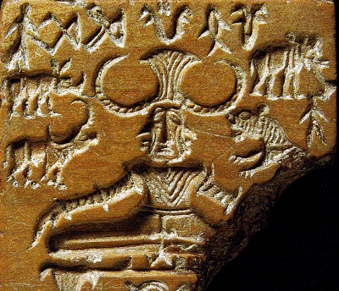
The Indus Valley religion is also mysterious because the language hasn't been translated. Historians believe they may have worshiped a Mother Goddess. They believe the Great Bath could have been used for some type of baptism. A small artifact has been found that some historians think may be a priest, but archeologists have yet to find a temple of any kind. Some of the Indus Script symbols are related to the images of the modern religion of Hinduism, but historians don't all agree about the symbols. The image to the left shows a three-faced person sitting in the lotus position. The lotus positions is a Yoga position of meditation where a person sits upright with their legs folded in their lap. Yoga is a spiritual practice of meditation, breathing, and body position used in many religions, especially Hinduism.
By 1500 BCE, the once vast and powerful civilization began to decline at some point it suddenly ended. Historians are uncertain why this area’s power declined. There are some theories that a great earthquake crumbled cities and changed the path of rivers, which caused them to move to a new location. Another theory claims the climate may have changed, which forced them to move. Yet another theory suggests invading armies destroyed some cities and forced most people to move. One thing we know for sure is that the civilization that once lived in this area ended and new people moved into this area.
Vedic Period
Around 1500 BCE, Indo-European people migrated to India. These people came from the area between the Black Sea and the Caspian Sea (purple on the map on the left). Between 4000 and 1000 BCE, Indo-Europeans migrated all over Europe and Asia. Some went to Europe and influenced the Romans and the Greeks; some settled in Turkey and became the Hittites, others migrated southeast instead. Some stopped in Iran, later becoming Persian, while others continued southeast to Pakistan and India. The slow migration did not arrive in northern India until about 1500 BCE. In India, the Indo-Europeans are sometimes called the Aryans.
Some people have disputed this arrival of the Indo-Europeans, however, the spoken language that these Indo-European people brought to India, recorded in Sanskrit, is very similar to other Indo-European languages such as Greek and Latin. There are many examples of similar words between the languages spoken in these areas. In addition, some DNA evidence supports the arrival of the Indo-Europeans to these regions. However, this is a theory of history that some historians don’t agree with. Hindu religious writing called the Vedas
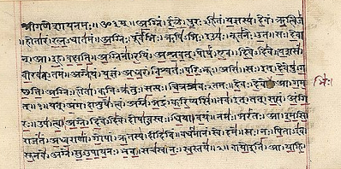
In addition to their spoken language, the Indo-Europeans brought their religious beliefs with them to India. The story and beliefs of Hinduism were recorded in a collection of stories and songs called the Vedas. There are many historians that believe the Hindu religion actually began in the Indus River Valley civilization. The Vedas were first written down in a language called Sanskrit. Sanskrit was a spoken language that was written down in different writing systems that developed later on such as Devanagari--the early form of Hindi (picture on right), India's main language today. Indo-Europeans also brought the domesticated horse into South Asia—this suggests the Indo-Europeans were at least semi-nomadic.

Ancient India
Indian Caste System
The Indo-Europeans first settled along the Indus River, in the same place where the Indus Valley people had lived. They settled down and mixed with the local Indian people. They lived there and eventually expanded throughout the Indo-Gangetic Plain. It was at this time that the caste system got started in India. It is believed that the Indo-Europeans had a similar division of their society, but historians don’t agree about how the caste system originated. The caste system is the permanent division of people into certain levels within society. Each level or caste has particular jobs such as merchant, warrior, or priest.
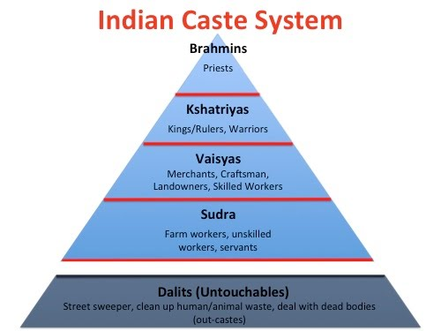
Castes were very important to people's identities. There were four castes, but there was another group below the four castes known as Dalits or Untouchables. Untouchables usually did the worst jobs, like cleaning up people's poop from the gutters, collecting garbage, and dealing with dead bodies. The lowest of the castes was the Sudras - the servants and farmhands who did not own their own business or their own land, and who had to work for other people. The largest number of people belonged to this caste. Above them were the Vaisyas, or farmers and traders, who owned their own farms or businesses. Above these people were the Kshatriyas, or warriors. The most powerful caste was the Brahmins (pictured below), the priests and other leaders. Many historians believe that when the Indo-Europeans arrived they treated the native Indus Valley people as the Untouchables.
There were also dozens of smaller groups within each castes. People who came from different castes could not eat together. Usually people from one caste did not marry or make friends with people from another caste. Untouchables were not allowed in temples and were seen as “polluted” compared to Brahmins who were “pure”. Today, the caste system is outlawed by the modern Indian constitution, and in urban areas most people ignore the caste traditions. However, in traditional rural areas caste divisions still exist. The developing Indian culture of the Indo-European mixed with native Indus Valley people began to grow quickly. Their civilization spread from the Indus River Valley to the Ganges River. Similar to other civilizations, kingdoms developed as the territory expanded.
Indian Kingdoms
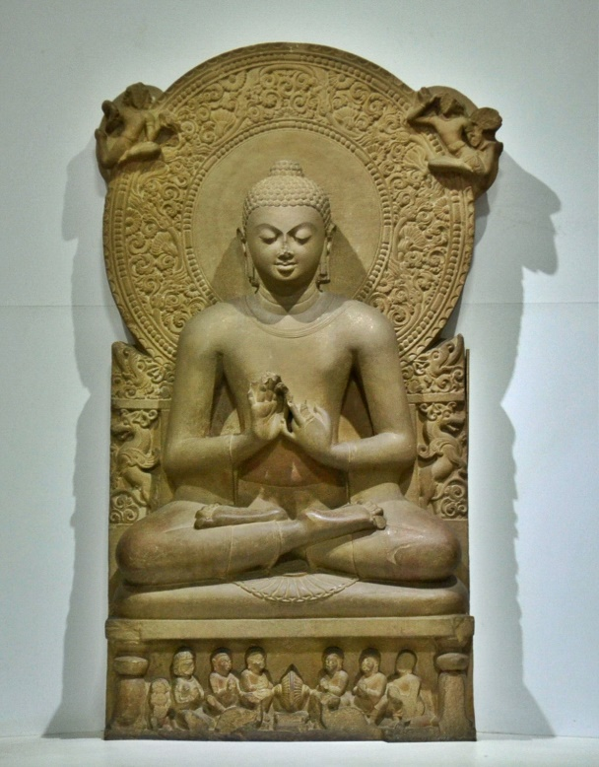
For about 1000 years the Indo-Europeans and native Indians mixed and migrated throughout the the northern part of the region. Cities began to grow in number, and size and by 600 BCE these slowly developed into 16 different kingdoms called Maha Janapadas. It was during this time period that Siddhartha Gautama gave up his title as a prince to search for truth and an end to the suffering. On his rare trips out of the royal palace, Siddartha noticed most people suffering through life. He also grew tired to the priests who dominated society. He gave up his royal life and started a quest to find real truth. After years of searching, he achieved “enlightenment” and became known as the Buddha or “enlightened one”. The Buddha traveled throughout South Asia and taught others his new ideas—these teachings became known as the religion of Buddhism.
Another religion called Jainism also developed during this time. Both of these new religions clearly developed from Hinduism in the same way Christianity and Islam clearly developed from Judaism. These new religions were a rebellion against cultural ideas such as the caste system and importance of priests in religion. Some of the first significant architecture in South Asia also came from these new religions. Since many of the building of the Indus Valley have been lost to erosion, Buddhist architecture has become India's most famous architecture. The first development is called a stupa. A stupa is a mound-like structure that contains the ashes and relics of a loved Buddhist leader. Later, the stupa transformed into a new Buddhist structure called a pagoda. A Pagoda usually has many levels or "tiers" of roofs. It is also a Buddhist temple. Today Buddhist pagodas can be found all over China, Japan and Southeast Asia.
Foreign Invasions
In 520 BCE, the Persians invaded and took control of northern Indian subcontinent. This conquest was under the mighty Persian leader Darius the Great. Persia controlled this region for about 200 years until Alexander the Great invaded South Asia. Alexander and his army were far from home and completely exhausted from years of constant war as they rampaged toward the east. It was in India that Alexander’s army finally refused to fight, and Alexander the Great was forced to return to Greece. The pattern of Persia conquest followed by Greek conquest occurred in Ancient Egypt, Ancient Iraq (Mesopotamia), and Ancient India. The only ancient civilization that didn't suffer from the Persian and Greek conquest is ancient China. This is mainly due the the barriers of geography. Ancient China is separated from these other areas of civilization by vast deserts and high mountains. These obstacles are very difficult to pass even in today's society. This is the main reason that China developed in a unique way. The Silk Road trade route between China and the rest of the world, over a 1000 years later would finally link all four major civilization areas.
The Persians and Greeks entered South Asia through the Khyber Pass, as did the Indo-Europeans, during their migration into South Asia. The Persians greatly influenced the style of government in India and some Greeks remained in northwest Pakistan and influenced the culture to this day, although the religion of Hinduism has had the greatest influence in India. The impact of the Indus Valley is not completely understood, but surely time and archeology will tell.

Ancient China
East Asia Geography
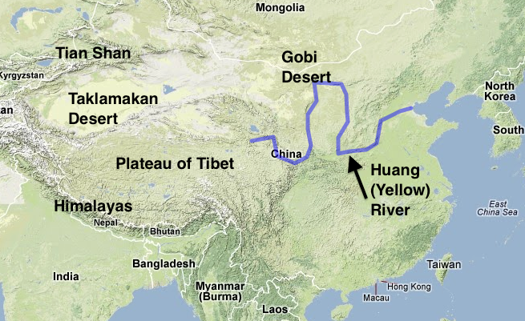
East Asia is home to long rivers, high plateaus, dry deserts, and rugged mountains. East Asia is similar to South Asia because rugged mountains and hazardous deserts create a deadly barrier to foreigners. For thousands of years, East Asian people were isolated from the rest of the world—this allowed them to develop their culture in a very unique way. Mountains dominate East Asia’s western landscape. The Himalaya Mountains are the southern border between China and India. The Plateau of Tibet is on the Chinese side of the Himalaya Mountains. Like the Himalaya Mountains, the Plateau of Tibet was also formed by the slow crash of the Indian subcontinent into Asia. Another Mountain range in western China is the Tian Shan. The name Tian Shan means “heavenly mountains”.
East Asia also has dry areas. The Gobi Desert is found along the border between Mongolia and China. The Gobi is the 5th largest desert in the world and is also the coldest. It is common to see frost or even snow on the sand and gravel dunes. Most of western China is very dry because of the rain shadow created by the Himalaya Mountains. A rain shadow is a dry area on the leeward (opposite of windward) side of a mountainous area. The mountains block rain-producing weather and cast a "shadow" of dryness behind them. The Taklimakan Desert is found in the dry west. It is framed by the Kunlun to the south and the Tian Shan to the north. There is very little water in the Taklimakan and crossing it is extremely hazardous. The mountains and deserts have played an important role in Asian history since they created natural barriers to outsiders.
Despite the dry and mountainous terrain of East Asia, there are some low plains suitable for early civilization. The North China Plain is an alluvial plain found along the Huang River on the east coast of China. Alluvial means it’s made of rich soil deposited by a flooding river. The North China Plain is the main area where farming is done in China. The main food grown in China is rice. Rice grows best in warm areas that have flooded fields—often called rice paddies (pictured on left). Since rice produces more food per acre than wheat, it can support a much higher population.
Heavy summer rains and snowmelt support 2 large river systems in East Asia. The Huang He or Yellow River is the 6th longest river in the world. It is called the Yellow River because the water picks up yellowish loess or silt from the western half of the river. The river is known for the amount of silt or small pieces of dirt it carries. Geographers estimate about 1.4 billion tons of silt flow into the Yellow Sea. Along the Huang in the North China Plain is where China’s early civilization began. The River is also called “China’s Sorrow” because of its deadly floods.
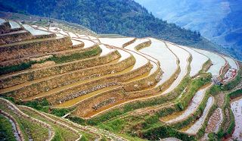
East Asia has many different climate types. Much of China has a Humid Subtropical climate. Another thing that effects the precipitation in East Asia is monsoon winds. Similar to South Asia, the summer monsoon brings heavy rain and the winter monsoon is very dry. More than two-thirds of China is covered in mountains and deserts. Arable land or land that can be farmed is an important resource. Only about 14 percent of China can be farmed. Many East Asian nations use terrace farming (pictured on right) by cutting “steps” into a mountain side and using the flat part of the “step” to grow rice.

Ancient China
Early History
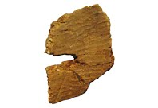
Humans probably reached East Asia between 30,000 and 50,000 years ago. Recently, pieces of clay pottery have been discovered in a Chinese hunter-gatherer cave that dates back to 18,000 years ago—this is the oldest pottery ever discovered. Historians believe farming began in China about 7,000 BCE. The first crop grown was a grain called millet. Rice was farmed around the same time, and may have come before millet. Farming created more food, which increased population and allowed people to do different jobs besides constantly looking for food. Eventually, people needed leaders to organize irrigation and store food. Families that controlled land and irrigation became powerful. So, civilization developed in China the same way it developed in South Asia, Southwest Asia, and North Africa.
Ancient China
It is difficult to be sure about China’s early ancient history. Most historians agree that civilization occurred sometime around 2000 BCE around the Yellow River. China was home to one of the four early civilizations found around the world. However, China is different from the other civilizations. The culture that developed in Ancient China became the nation of China that exists today. Of course there have been changes along the way, but the same culture has continued. The other three civilizations have faded away or been completely overtaken by new people. For this reason, people say China is the oldest continuous civilization in the world. In China, the powerful families that controlled land became leaders of family-controlled governments called dynasties. Chinese history from ancient times until about 100 years ago is divided by different dynasties.
Xia Dynasty
The Xia Dynasty (2000 BCE-1600 BCE) was the first dynasty in Chinese history. It lasted around 500 years and included the reigns of 17 emperors--an emperor is similar to a king. The Xia people were farmers, with bronze weapons and clay pottery. One artifact called a "bi" seems to be a burial artifact. Bi's have been found throughout Chinese history. Silk is one of the most important products China has ever created. Most historians agree that the Xia Dynasty was producing silk clothing, though silk production may have started much earlier. Silk is made by unraveling the cocoons of Silk Worms. Each cocoon is made from a single silk thread. Not all historians agree that the Xia was a real dynasty. Some believe the story of the Xia were just a mythical story because the stories sound embellished and they don't match exactly with the archeology that has been discovered so far. The Xia stories come from written history from the next dynasty, but there are some artifacts to support the existence of the Xia Dynasty.
Shang Dynasty
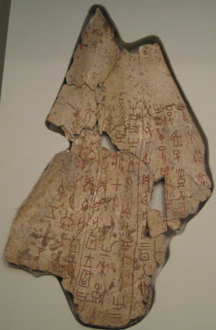
The Shang Dynasty (1600 BCE-1046 BCE) was originally a clan living along the Yellow River during the Xia Dynasty. A clan is group of very close families that are often viewed as one big family. The Shang conquered Xia land and gained control of Chinese civilization. The Shang Dynasty lasted over 600 years and was led by 30 different emperors. The Shang were the oldest Chinese civilization to leave behind written records, called oracle bones—turtle shells, cattle shoulders or other bones on which were written important clues to Chinese history. Oracle bones were often used to determine what the gods/nature wanted. If the kingdom needed to know something such as 'will the king have a son' or 'should we go to war', it would be carved into bone or shell. They would then heat the bone until it cracked. The crack lines would reveal the wishes of the gods--this process of learning what the gods want is called divination. During the Shang Dynasty people worshipped many gods. Ancestor worship was very important since they believed their family members became god-like in the after-life. Shang government invented new ways to make bronze crafts. Thousands of bronze artifacts have been found including some that weigh nearly 2000 pounds. It’s important to understand that other smaller cultures existed in the same time as the Shang in different parts of China, but the Shang left written records and seem to be the most advanced. Eventually, the Shang were defeated by the Zhou clan.
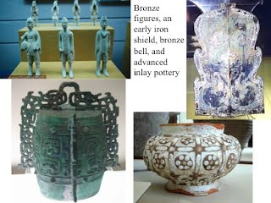
Zhou Dynasty
The Zhou Dynasty (1046 BCE-256 BCE) lasted longer than any other dynasty in Chinese history. The Zhou time period is divided into parts called the Western Zhou and Eastern Zhou because there was a brief disruption in their control of the government. The Zhou battled with invading armies from the north (Mongolians), so they built large mounds of dirt and rock as barriers that would slow down the enemy--this was not the Great Wall yet, but the idea came before the wall. The crossbow was another invention of this time--it was extremely effective and feared by enemies. During the Zhou, the use of iron was introduced to China, which begins the Iron Age in China. Iron tipped weapons were much stronger, and the iron plow helped to increase food production.
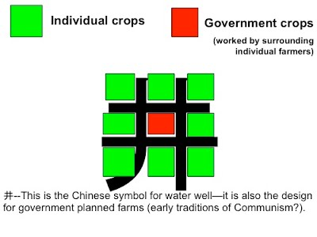
Agriculture was usually directed by the government. All farming lands were owned by nobles (wealthy). They allowed peasants to farm the land similar to the feudal system that developed in Europe in the Middle Ages. The government directed farming by dividing a piece of land into nine squares in the shape of the character for "water well," (井), with the grain from the middle square taken by the government. The individual farmers kept the square of grain in the surrounding squares and worked the middle square together. This allowed the government to store extra food in case disaster struck.

Ancient China
Ancient Chinese Religion
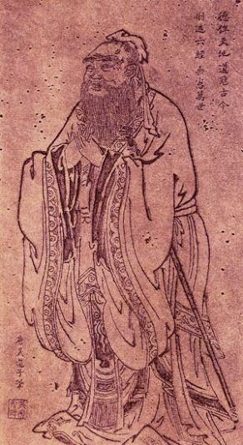
During the Zhou Dynasty Taoism (also spelled Daoism) and Confucianism developed—the two most important Chinese philosophies. The great Chinese philosopher Confucius developed a way of life called Confucianism. Confucianism says that all people can be taught and improved if they do the right things. People should focus on doing the right thing for others, make family the most important, and respect elders of society. Confucianism is still important today, but it did not become widely followed in China until the Han Dynasty. The founder of Taoism was named Laozi. Taoism is all about following the "Tao", which means the "way" or "path". The Tao is the driving force behind all things in the universe. The Yin Yang symbol is usually associated with Taoism. Taoists believe you should live in harmony with nature, be humble, live simply without too many possessions and have compassion for all life. These philosophies are different from religions because they don't have an all-powerful god or gods, although the idea of ancestors and nature are often treated like gods. The power of the emperor was also related to religious beliefs. The Zhou talked about the Mandate of Heaven as the law that allowed Chinese emperors to rule—it said that the ruler was blessed by Heaven to rule the people. If he lost the blessing of heaven he should be removed. Things that proved the ruling family had lost the Mandate of Heaven were natural disasters and rebellions. For example, if a draught or flood was particularly bad, people may begin to think the ruling family had lost the Mandate of Heaven.
By 475 BCE the provinces/states of the Zhou kingdom were more powerful than the Zhou central government. The states rebelled and fought one another in a series of brutal wars, which began a period of over 200 years of war called the Warring States Period. Eventually, one family (Qin) united all others into one empire. This is usually recognized as the first empire of China, which begins a new time period called Imperial China. Imperial basically means "empire of".
Imperial China
From 221 BCE to 206 BCE the Qin Dynasty (pronounced "chin") gained control of civilized China. The Qin didn’t last very long, but made an important impact on China’s future. The Qin expanded their territory and created China’s first empire. The brutal leader Qin Shi Huang declared himself the first true emperor of China. This dynasty designed standard currency (money), standard wheel axle size (to make roads all one size), and standard laws that applied to the entire empire. Standardize means to make the same. The Qin also standardized the different systems of writing into one system called small seal script that much of China still uses today. Qin Shi Huang enforced a philosophy called Legalism that focuses on people following laws and taking instructions from the government. However, many followers of Confucianism were more loyal to their family and other Confucian traditions. To silence their protests, the emperor banished or put to death many Confucian teachers and burned their Confucian books. At one point Qin Shi Huang killed 460 Confucian teachers by burying them alive!
Mongolian invasions from the north were a constant problem in China. The Qin government ordered walls built in the past to be connected to make a larger and stronger wall. This is usually recognized as the beginning of the Great Wall of China. Despite what you might think, the building of the Great Wall was unpopular with the people who saw it as a waste of resources. Each dynasty built new wall or improved the previous dynasty's wall. Most of the Qin Wall is gone today or been replaced. The wall that still exists today was mainly built by a later dynasty called the Ming. A number of public projects, including canals and bridges, were also built to help strengthen trade and transportation.
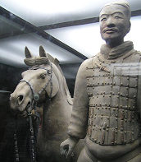
An amazing tomb larger than a football field or anything in Ancient Egypt was made for the emperor. It is still sealed, but legend says there are rivers of mercury and models of the entire Chinese empire inside. Outside the tomb is a life-sized army of clay soldiers, discovered in 1974 CE. This is known as the Terra Cotta Army. Terra cotta means baked clay. There are over 8,000 unique soldiers, over 600 total horses, 130 chariots, as well as acrobats and musicians--all made of clay! Archeologists are still trying to put them back together as most were broken into pieces over time. Although the Qin Dynasty was short-lived, its standardization of Chinese life left a deep impact on later dynasties in China. It is from this dynasty that we get the name “China”. The first emperor died in 210 BCE and was replaced by a weak and young son. Eventually, rebellion started and a member of the Qin army took control of the empire, which began a new dynasty.
The Han Dynasty began in 206 BCE and lasted 400 years until 220 CE and is considered to be one of the greatest periods in the entire history of China. Like the Zhou Dynasty, the Han Dynasty is divided into Western Han and Eastern Han because of a short disruption when someone tried to replace the Han family--they were unsuccessful. Han culture defines Chinese culture today. In fact, most Chinese citizens today claim "Han" as their ethnic background. The government made Confucianism the official belief system of the empire. The empire grew greatly during this time, conquering land in modern Korea, Mongolia, Vietnam, and even into Central Asia. The empire had grown so much the emperor needed a larger government to rule it. He started a system of examinations (tests) to find qualified people to do civil (government) jobs such as tax collecting. This system called Imperial Examinations. In fact, most nations use a similar system to find qualified people in a fair way.
Industry and Trade
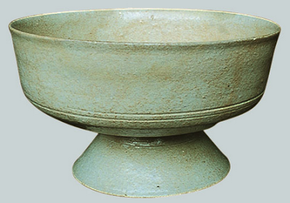
Many things were invented during this time including paper, steel, the compass, and porcelain. Porcelain is a very hard type of ceramic (clay pottery) used to make crafts that were highly valued by people around the world. Porcelain is made from special clay that is heated until it melts and basically turns to glass. Porcelain dishes, cups, and bowls are often called "China" because until a few hundred years ago, all porcelain was produced China. The Han Dynasty was also known for its military power. The empire expanded westward as far as the edge of the Taklimakan Desert, which allowed the government to guard the trade traffic across Central Asia.
The paths of caravan traffic are often called the "Silk Road" because the route was used to export Chinese silk. The Han dynasty also extended and fortified the Great Wall to protect the Silk Road. Another important product of the Silk Road was the religion of Buddhism which reached China during this period.
Chinese dynasties would continue to rule China until Medieval times when the Mongolians finally conquered China. Chinese families eventually fought back and regained control, which they maintained until 1911 when China experienced a civil war. Again, China is unique because they have continued the same culture since ancient times. There are very few examples of architecture from Ancient China or even Imperial China. The reason is because China primarily used wood as its main building material. Similar to Ancient Iraq (Mesopotamia), very few ancient structures exist today.

