LANGUAGE

The language spoken by the Sumerians is a bit of a loner. That’s because it doesn’t belong to any known language family. (For example, modern English belongs to the Indo-European family.)

But even though we can’t easily classify it, we still know a lot about the Sumerian language, thanks to the writing they left behind! Hundreds of thousands of clay tablets containing cuneiform (pictured)—the form of writing invented by the Sumerians—have survived to this day.
Scholars have even discovered cuneiform dictionaries that were created around 1800-1600 B.C.E. Using these texts, experts have figured out that Sumerian was a language that used morphemes, or units of meaning, to create words.
The earliest and most important words—there were about a thousand—got their own cuneiform symbols. These basic symbols were then pieced together to create compound symbols, which were used to represent more advanced words and ideas. It was a good system; Sumerian continued to be the language of religion and law in Mesopotamia long after the fall of Sumerian civilization!
By the way, the word Sumer wasn’t actually a Sumerian word! It was developed only after Sumer was conquered. The Sumerians called their own civilization "Ki-En-Gir," which means "Land of the Lords of Brightness!"

Religion
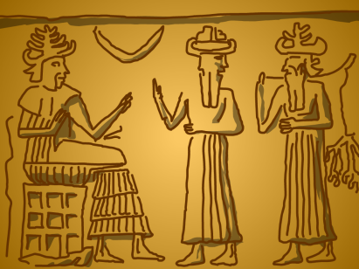
One god per city—that’s the best way to describe the religious structure of Sumer. The Sumerians were polytheistic, meaning they believed in more than one god. But each Sumerian city-state had a sort of patron-god that it worshipped exclusively.
The Sumerians believed that the gods used their ziggurat temples almost like staircases to descend to Earth! Their main god was Anu, the god of heaven (the word “an” means “sky” in Sumerian), who joined with Ki, the goddess of Earth, to give rise to a group of gods and goddesses called the Anunnaki, which translates loosely as “children of the lord.”
Among these were Enki (pictured, seated), the god of water who was the chief deity of the city of Eridu; Enlil, the lord of the wind who was worshipped in the city of Nippur; Utu, the sun god of the city of Sippar; and Nanna, the moon god of the city of Ur. As different cities became more or less powerful politically, the religious importance of the gods associated with those cities also shifted!
Sumerians believed that the universe was a flat disk enclosed by a tin dome, and that the gods created human beings out of clay to serve them. They also believed that the afterlife was not a fun place—after someone died, they were cursed to spend eternity wandering around the netherworld as a ghost!

ARTS AND ENTERTAINMENT

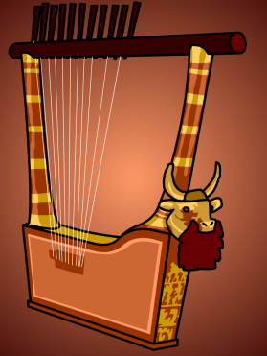
Music is in the air…even in the Bronze Age streets of Sumer! From the different types of musical instruments found in royal burial sites to the images of musicians in artwork, it’s pretty clear that music played a major role in the everyday lives of the Sumerians.
Music and dancing were part of many religious celebrations, as well as celebrations for marriages and births in the royal families. Music also was used as a backdrop for reciting poetry, a practice later seen in Ancient Greece. But outside of these specific purposes, it doesn’t seem like music was played just for pure enjoyment—which means no concerts in Sumer!
The most popular instrument in Sumer was the lyre, a stringed instrument that is strummed like a guitar. Musicians would wash their hands before playing stringed instruments, to purify them.
The lyre pictured here is shaped like a bull, which is a symbol of fertility and divine power in Sumerian culture. In addition to lyres, dancing girls would often use clappers to provide rhythm, and drums and wind instruments were eventually developed as well. Musicians received training in special schools, leading to the formation of a whole new professional class in Sumerian society.

CAREERS

If you were looking for a good job in Sumer 5,000 years ago, your best bet would be to become a scribe, a professional writer. Writing was one of the most valuable skills in Sumerian society—and since very few people knew how to do it, pros were always in demand, primarily as record-keepers for kings and priests.
The catch? It took a lot of learning and hard work to become a scribe! Some of the first known schools in history were set up to teach Sumerian boys the new invention of writing, which was first introduced around 3100 B.C.E. Students normally started attending these schools at the age of eight and stayed on for about 10 years.
Once they graduated, they became some of the most respected members of Sumerian society. They recorded inventories of farm animals; trades and transactions; laws; personal and business letters; marriage and death certificates; taxes; gifts for the gods; hymns and prayers; and scientific texts. Military scribes calculated food and weapons supplies for armies, and government scribes calculated the number of laborers needed to build canals.
Many of these writings have survived in multiple copies, because students learning to become scribes transcribed them over and over again for practice! All scribes wrote on clay tablets (paper hadn’t been invented yet). Once the soft, wet clay was shaped into flat surfaces, scribes used a sharp tool called a stylus to make their marks. When the clay dried, voila! A permanent record!

